Final Code Execution

- Open https://trailhead.salesforce.com Click Login salesforce then enter username and password as:
Username: aishwaryareddy.sarsan@creative-fox-ixrdes.com
Password: Health@1
- Click remind me later You will be prompted to salesforce login page.
- Click on switch to lightening experience Object manager create custom object(this is were we created the Patient object we already created it)
- Click on app launcher( 6 dots on the left side) Search for patient(Then patient record page will be opened) In the patient drop down click on my view you will be there are no records in the org.
- To insert records you can do it either with data import wizard (which can be found by searching in quick find on the left side) or you can search for data loader app and install it(can be found by searching in the left hand side). You can insert the records by upload the CSV file “Copy of patient.csv” by attaching the file included in zipped directory.
- Update 10 records with tomorrow’s date and rest all with tomorrow’s date and the upload the csv.
- Then to run the apex batch classes click  Developer console File Open Classes then select and open AppointmentReminderBatch, AppointmentCompleteBatch, AppoinmentAdmitBatch which are the apex batch classes which can be concurrently to process large data upto 50 million records in batches.
- You can also open the test classes for these classes in the same way by opening AppoinmentReminderBatchTest, AppointmentCompleteBatchTest, AppointmentAdmitBatchTest.
- To run these classes click Debug Open Execute Anonymous Window paste

AppointmentReminderBatch batch = new AppointmentReminderBatch();
Database.executeBatch(batch,5);

AppointmentCompleteBatch batch1 = new AppointmentCompleteBatch();
Database.executeBatch(batch1, 2000); // 10 is the batch size

AppointmentAdmitBatch batch2 = new AppointmentAdmitBatch();
Database.executeBatch(batch2, 2000); // 10 is the batch size
- Select these three texts and click Execute highlighted The three batch jobs will start running concurrently.
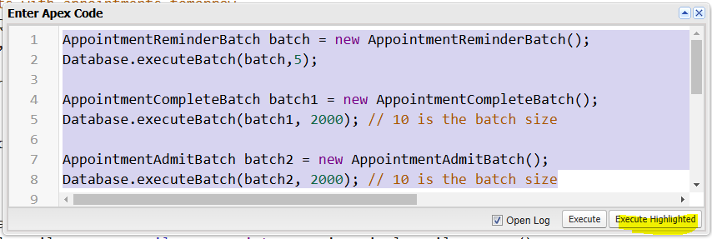

- To track the progress go back to salesforce Quick find Search for Apex jobs you can see the batch see the time the batched started executing at the same time.

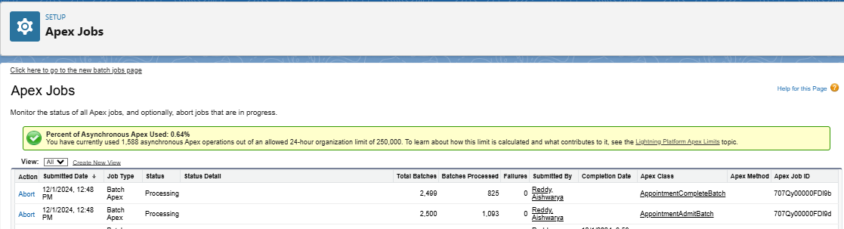
- But the Job run asynchronously so incase there are any dependent tasks this is not feasible which is why we have included queueable apex which help in chaining up the tasks.
- To run the queueable classes open queueable1 and queueable2 classes Then to run then open developer console click debug open execute anonymous window copy and paste the below command
System.enqueueJob(new Queueable1());
- Then select the text and click on execute highlighted.
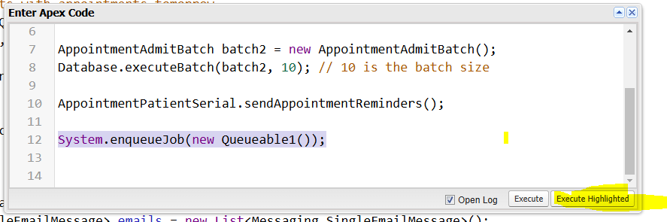

- To track this Salesforce Quick find apex jobs you can see the classes are executed in the order mentioned.
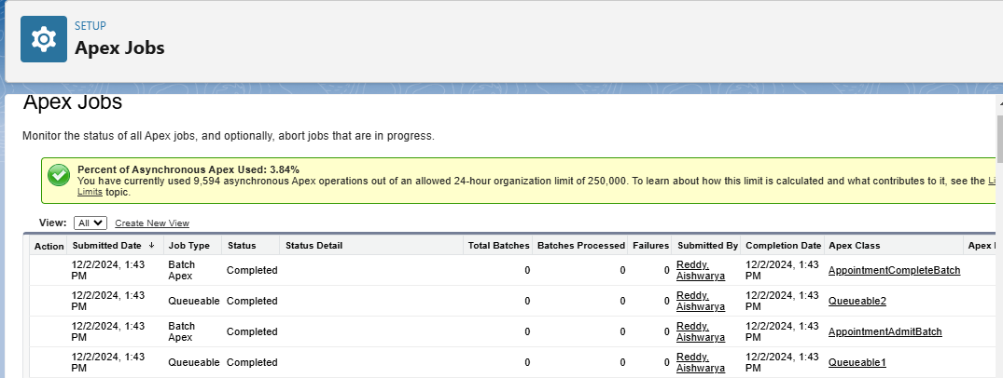
- This is how we have implemented and utilized parallelism

